3 6 9 a i . B i z

KRA / KPI

  - Admin Guide
Set up your team and clients, triage the work, watch the day live, and invoice it.

About the Admin Role
As an Admin you run the system. You create the structure the work hangs off, you decide which tasks are real, you watch the day as it happens, and you turn finished work into invoices.
The app shows three roles: Admin, Client and User. Anyone with coordinator, owner or system-administrator rights shows as Admin — there is one badge, not three.
TIP Admins are never locked out by the workday gate. A User must tap Start Workday before they can touch anything; you can act at any time, on any task.

Your Day at a Glance
▪ Morning — clear Pending Review: accept or send back the tasks people raised themselves
▪ Through the day — keep Live Tracking open to see who is working and who has stalled
▪ As work lands — approve or reject finished tasks so they move on to the client
▪ End of day — check Daily Reports and Workday Snapshots
▪ Weekly or monthly — use Owner Dashboard and Client Invoices to bill signed-off work

PART 1 FIRST-TIME SETUP

Step 1 Connect the Device to Your Server
On a brand-new install you first point the app at your Odoo server. Enter your Server URL, wait for the database list to load, pick your database from Select a database, then enter your Odoo Username or Email and Password, and tap Login.
This sets the device up — it does not log a person in. Users still sign in with their own mobile number afterwards.
TIP To reach this screen again later, tap the 369 logo seven times on the sign-in screen. It is deliberately hidden so ordinary users cannot repoint the app by accident.

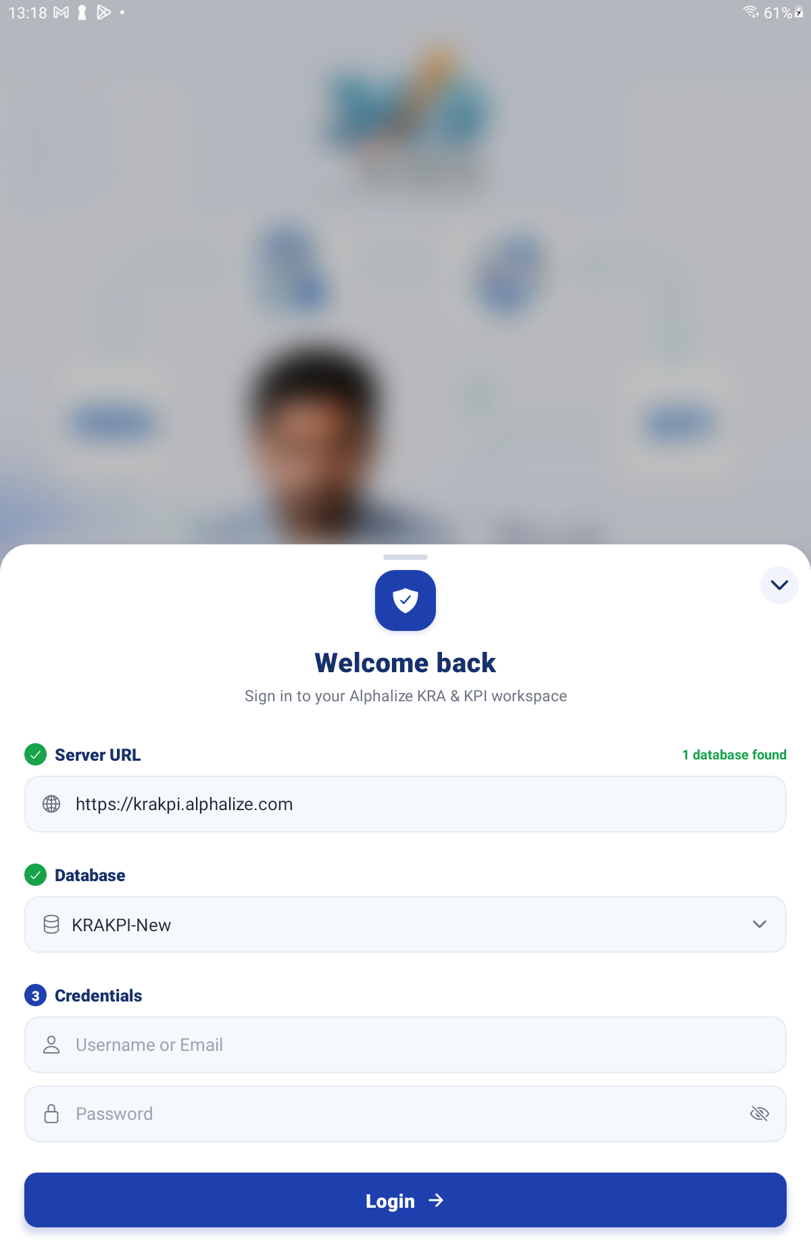
The Connect screen — Server URL, database picker, username and password

Step 2 Log In and Reach Home
Sign in with your own mobile number and password, exactly as everyone else does. Your Home screen carries every tile, grouped under KRA / KPI, Reports and Settings.
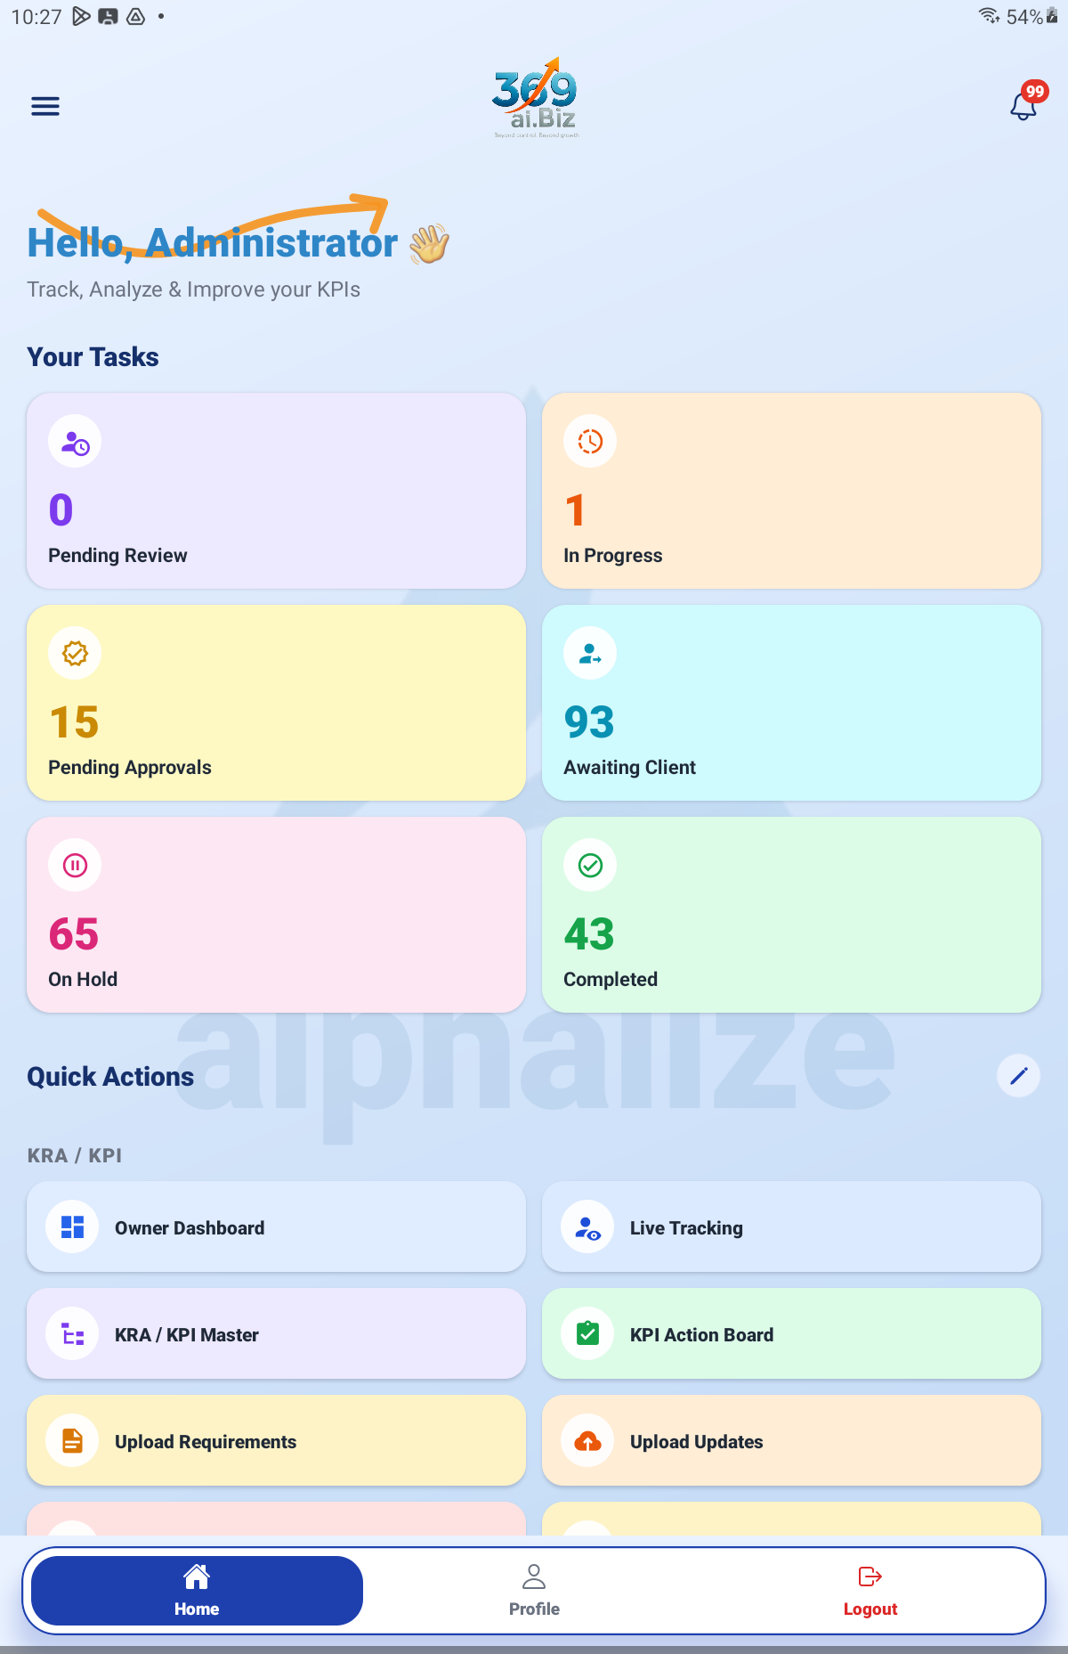
Admin Home screen — the stat strip and the full Quick Actions grid

Step 3 Set Your Company Branding
Open Company Branding. Set your Company Name, then use Choose Image to upload your Company Logo (or Remove to clear it). Tap Save Branding.
This is what appears on the PDFs your clients receive — invoices and reports — so do it before you send anything out.
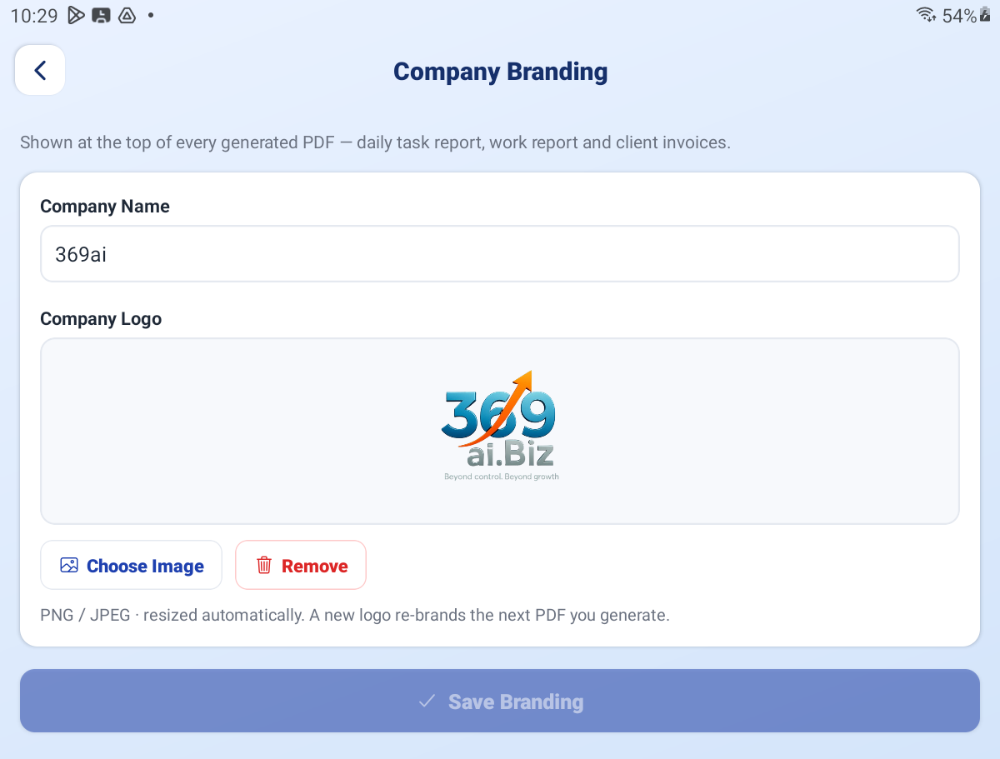
Company Branding — name, logo and Save Branding

Step 4 Work Through Configuration
Open Configuration. Every setting saves itself as you change it — a tick flashes to confirm. There is no Save button.
Card 1 — Timers
Setting | What it controls
Client approval window (minutes) | How long a client has to approve an assigned developer before it releases on its own.
Queue re-nudge gap (minutes) | How often a client is reminded about a task sitting unread in their queue.
Urgent re-nudge gap (minutes) | How often an unread urgent pause is chased.
Standard workday (hours) | The working day length everything is measured against.

Card 2 — Daily Task Report & Retention
Setting | What it controls
Send daily employee task report (PDF) | Turns the automatic daily report on or off.
Send time (IST) | What time of day it goes out.
Report covers | Whether it reports the Previous day or the Same day.
Keep workday snapshot images for | How long end-of-day snapshot images are kept. Set 0 to keep them forever.
Keep generated report PDFs for | How long generated PDFs are kept before being purged.

Card 3 — Developers — Multi-task & WhatsApp
One row per person. For each you can:
▪ Turn Multi-task on, letting them run more than one task at a time.
▪ Set their WhatsApp number — this is where their login codes go.
▪ Tap the dial-code badge to set their country, which sets the dial code and expected number length for their login.
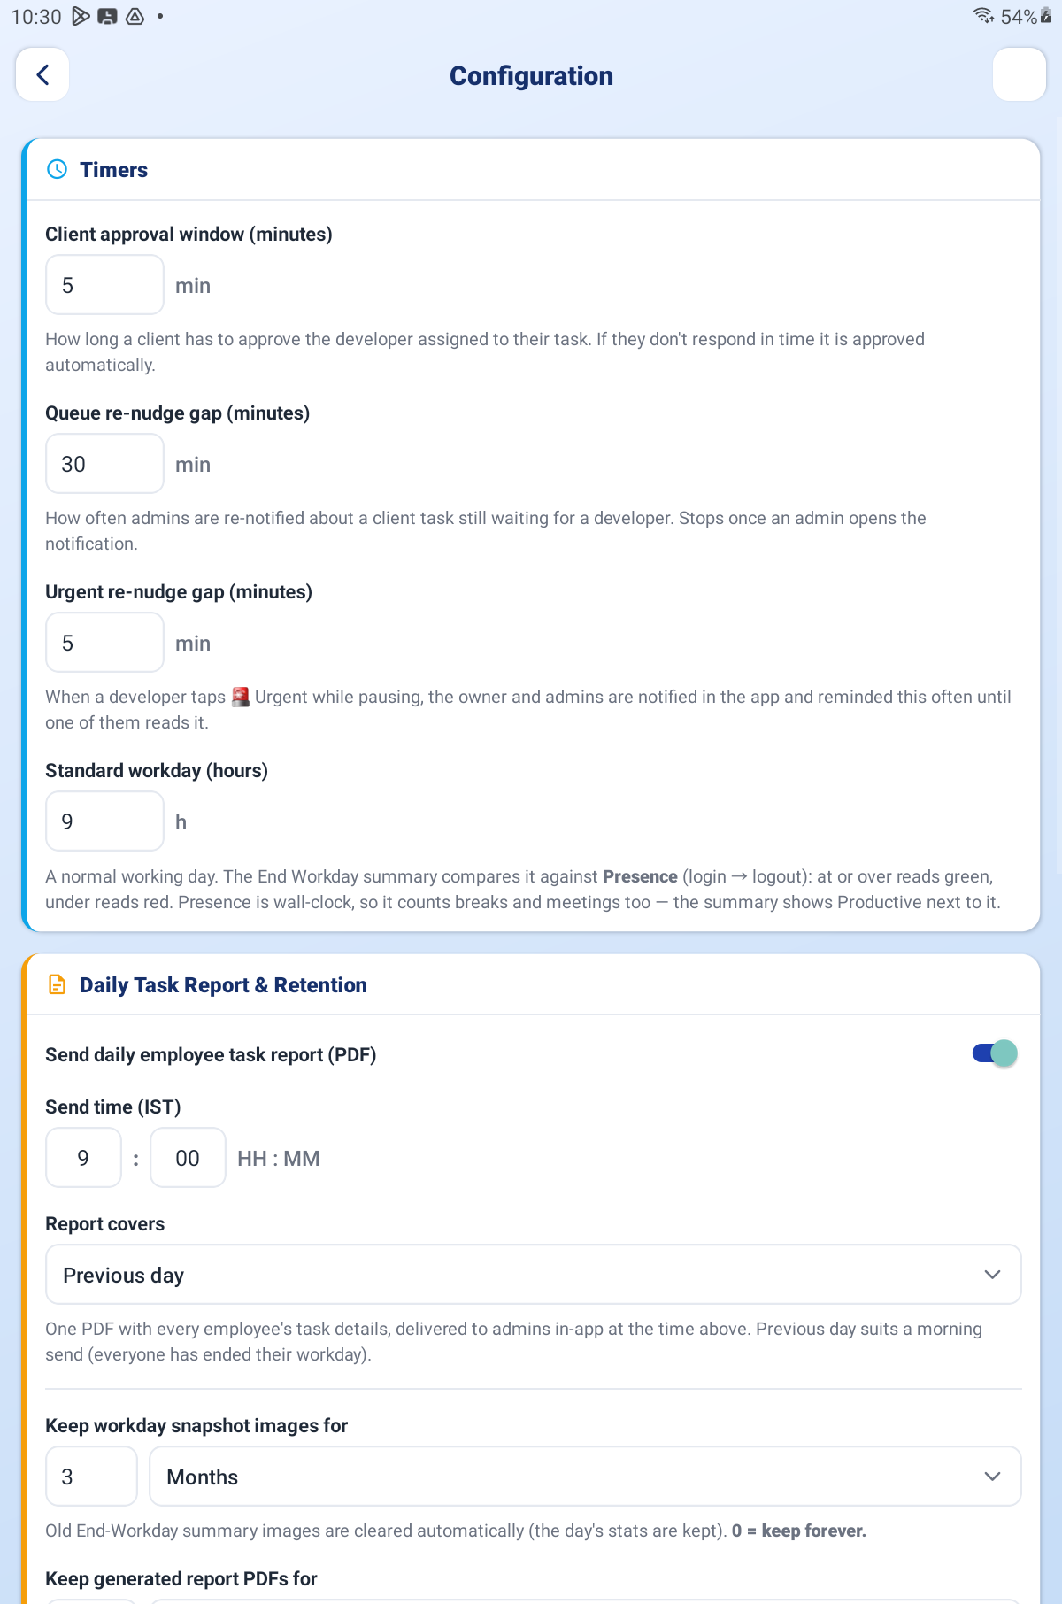
Configuration — the Timers card and the Daily Task Report & Retention card

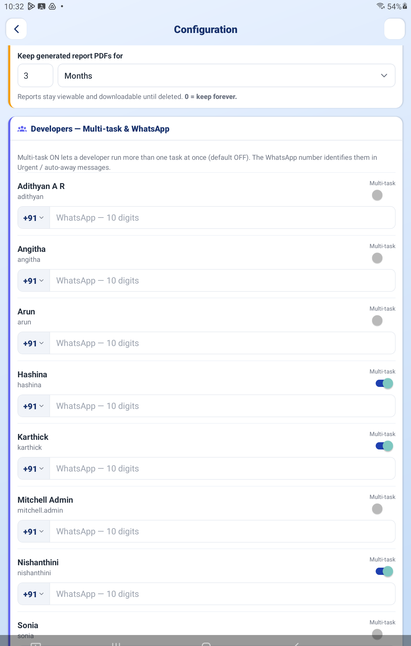
Configuration — the Developers card with the Multi-task toggles

Step 5 Add Your People in Users
Open Users. Each person shows their Name, Login, Email, KRA / KPI Role, Mobile and whether they are Active. Use the Active and Archived tabs to switch between current and former staff.
The KRA / KPI Role is the important field. It decides everything the person can see and do:
Role | Who it is for
Admin | You and your coordinators. Full access.
Client | External customers. They see only their own work.
User | Your team members who do the work. Board, workday and their own records.

You can also Change Password for someone, or Reset password to 1111 if they are locked out.
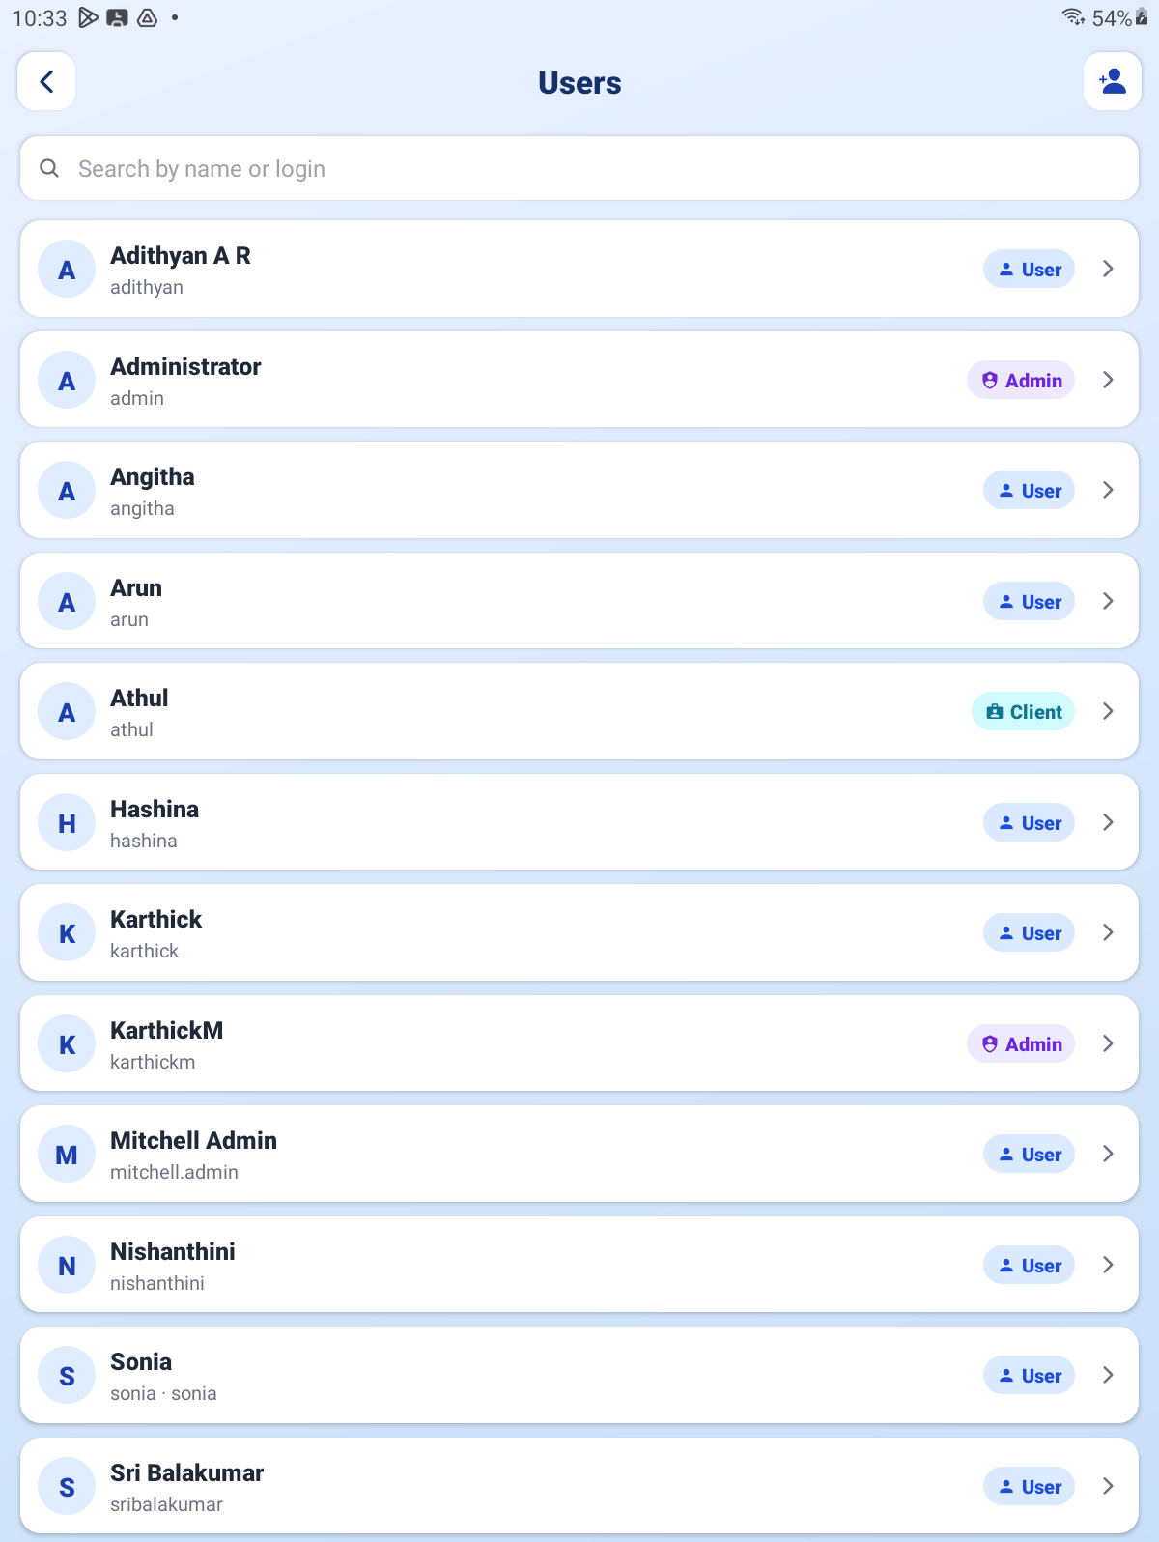
The Users screen — the list with the KRA / KPI Role column and the Active / Archived tabs

Step 6 Set Up Logins and WhatsApp
Open Login Management. It has three parts:
▪ Team Members — each person's role and mobile, a switch to allow or block their login, and Reset to 1111.
▪ WhatsApp sender — scan the QR code to connect the number that sends your login codes. Its status is shown here, and Disconnect unlinks it.
▪ Message template — the wording of the login code message, with a Preview.
IMPORTANT Login codes are delivered over WhatsApp. If the sender is not connected here, nobody can reset their password. Check this screen first whenever someone reports they cannot get a code.

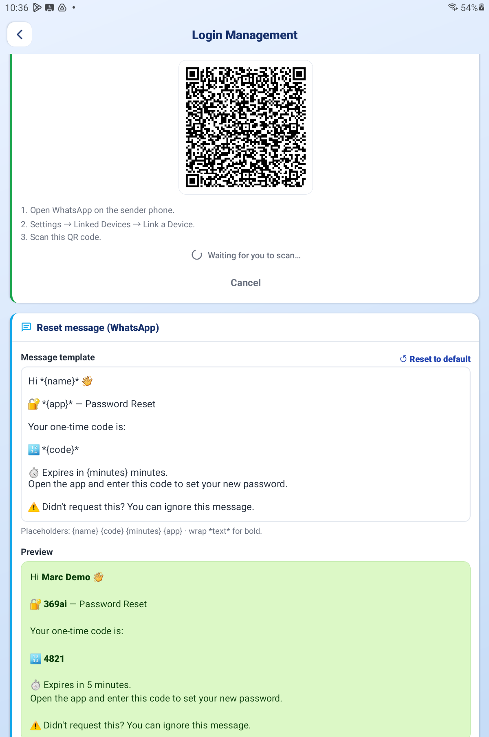
Login Management — team members, the WhatsApp QR panel and the message template

PART 2 BUILDING THE KRA / KPI STRUCTURE

Step 7 Understand the Three Levels
Open KRA / KPI Master. Everything is a tree with three levels:
Level | What it is | Example
KRA (top) | Your client. | Alphalize
Sub-KRA | A project or phase for that client. | Phase 2
KPI | The actual task someone works on. | Build the login screen

Step 8 Create and Edit
▪ Tap KRA + to add a client or a project under one.
▪ Tap KPI + to add a task under a project.
▪ Tap the pencil to rename anything.
▪ Tap the trash to delete. You will be warned that this also deletes everything beneath it and cannot be undone.
IMPORTANT Deleting a KRA deletes every project and task under it. There is no undo. If you only want it out of the way, rename it rather than delete it.

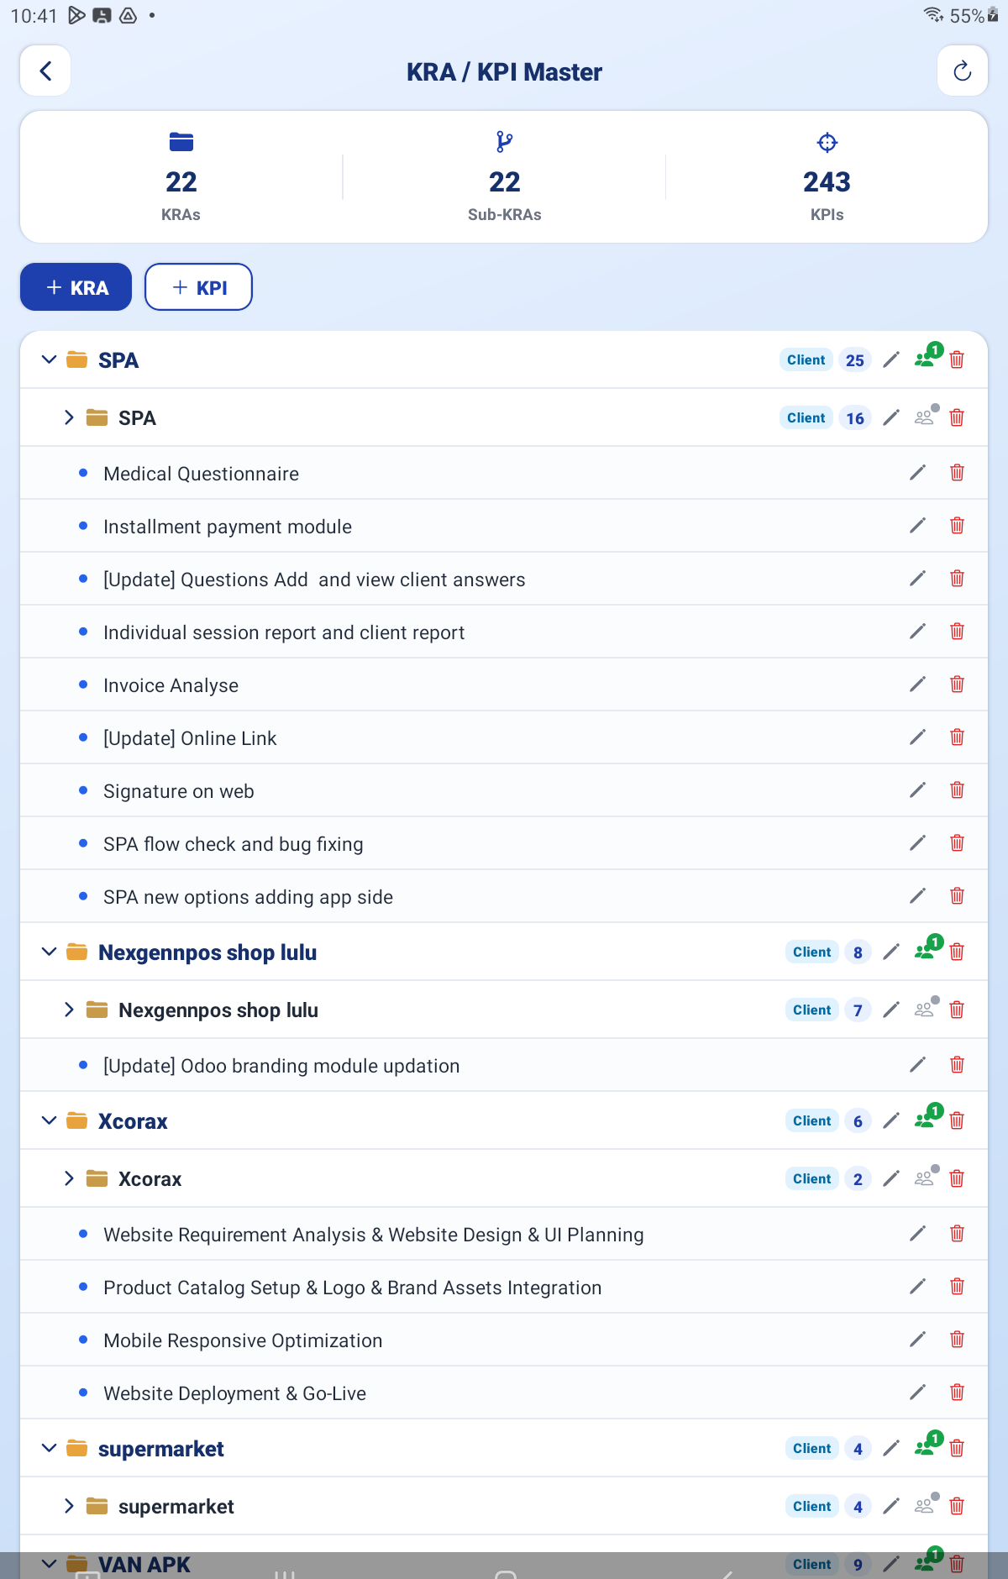
KRA / KPI Master — the tree with the KRA + and KPI + buttons

Step 9 Give the Client Access
Open a KRA and use Assign clients to say which client logins can see it. If you have not made any yet, the sheet tells you: “No client logins exist yet. Create one in Login Management.” You can create the client login from here.

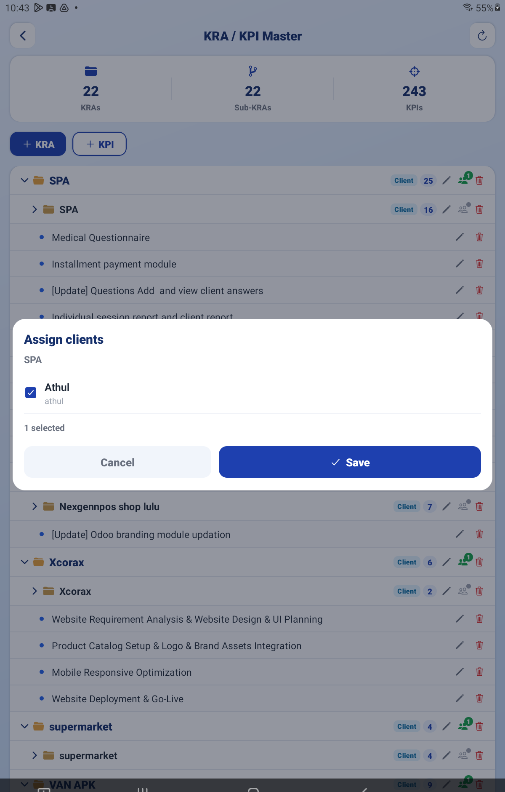
The Assign clients sheet

PART 3 GETTING WORK INTO THE SYSTEM

Step 10 Work the Client Task Queue
Open Client Task Queue. This is where work your clients have sent in waits to be turned into proper, assigned tasks. Drill down: Date → Client → Task.
Open a task and fill in the details:
Field | What to put in it
Ref ID | Filled in for you. Override only if you must.
Task Name | Rewrite the client's wording into one clear job if needed.
Description | The detail the developer needs.
Estimate Hours / Minutes | How long it should take. This drives reporting and per-hour billing.
Priority | Regular, Important or Urgent — this decides which lane it lands in.
Linked Req | For updates and bugs, the requirement they relate to.
Assign Developer | Who is going to do it.

Then choose:
▪ Save — keep your work without releasing it yet.
▪ Save & Publish — release it. The client is asked to approve the developer, and the work can begin.
▪ Discard — throw the changes away.
IMPORTANT If you see the banner “Client rejected the assignment — needs a new developer,” the client turned down the person you picked. Assign someone else and publish again. Their reason is on the task.

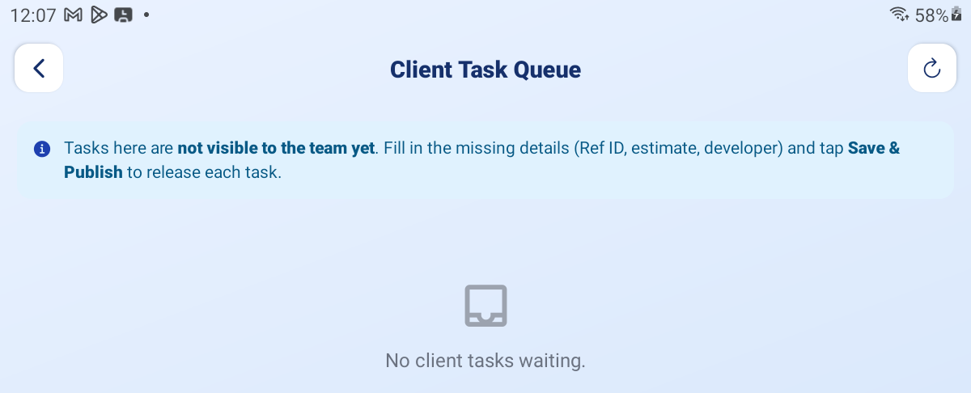
Client Task Queue — the task form with Assign Developer, Save and Save & Publish

Step 11 Bulk-Upload Work Yourself
Upload Requirements, Upload Updates and Upload Bug Reports let you raise many tasks at once. All three work the same way and differ only in the reference they generate:
Screen | Ref | For
Upload Requirements | REQ | New work.
Upload Updates | UPT | Changes and amendments.
Upload Bug Reports | BUG | Defects.

The screen has four sections:
▪ 1 Destination — Client (Root KRA) → Project / Sub-KRA → Version.
▪ 2 Source & Bulk Import — paste text, import an XLSX/CSV, or Download Blank Template.
▪ 3 the task rows — editable, with Add Row and attachments.
▪ 4 Defaults for new rows — the hours, minutes, priority and developer every new row starts with.
Tap Create All Tasks when ready. Anything that fails gets a Retry failed button.
TIP Set Defaults for new rows before you import. It saves setting the same developer and priority on thirty rows one at a time.

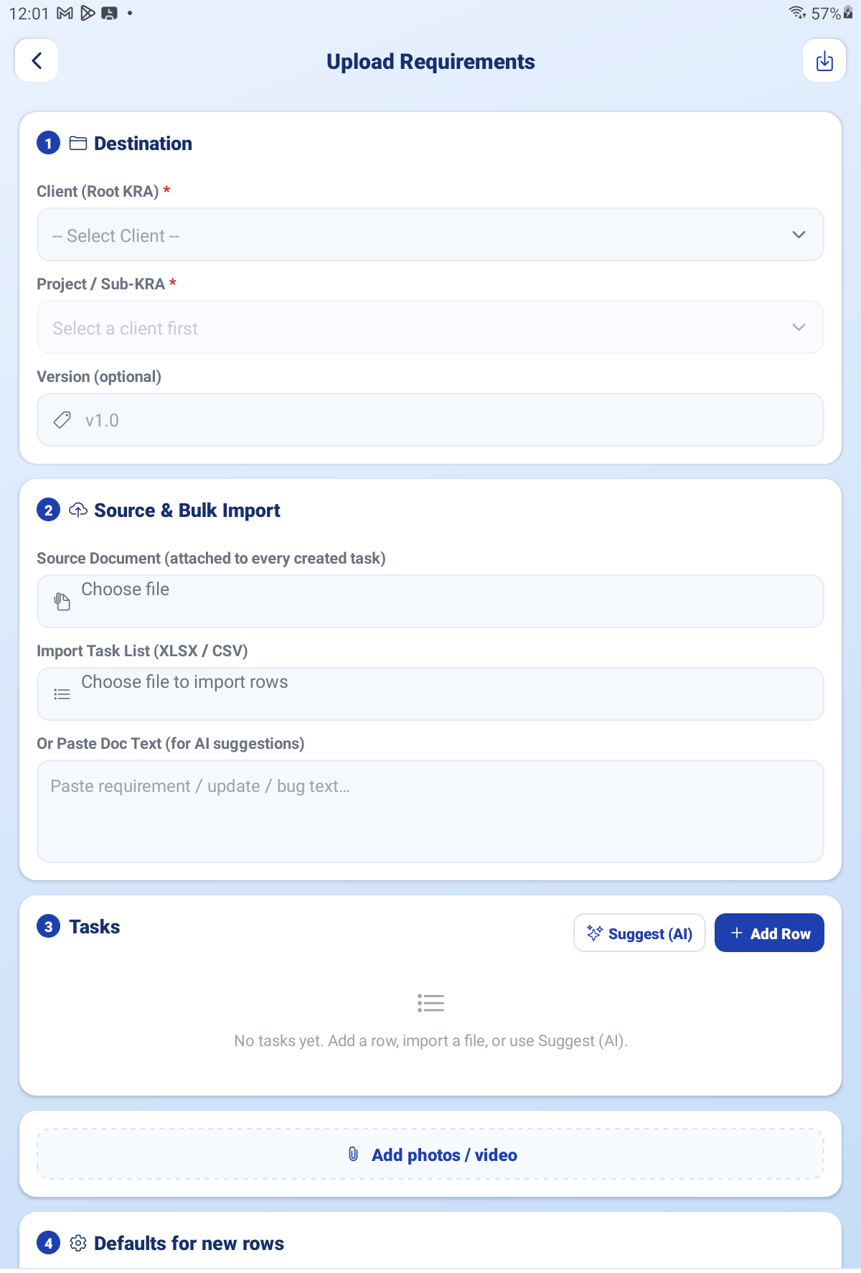
Upload Requirements — the four numbered sections

Step 12 Generate Client Files
Open Generate Client Files, pick a Client, a Project and a Version, and choose whether to include existing tasks as data. You get a ZIP containing three spreadsheets — Requirements, Updates and Bug Reports — ready to send to the client to fill in.
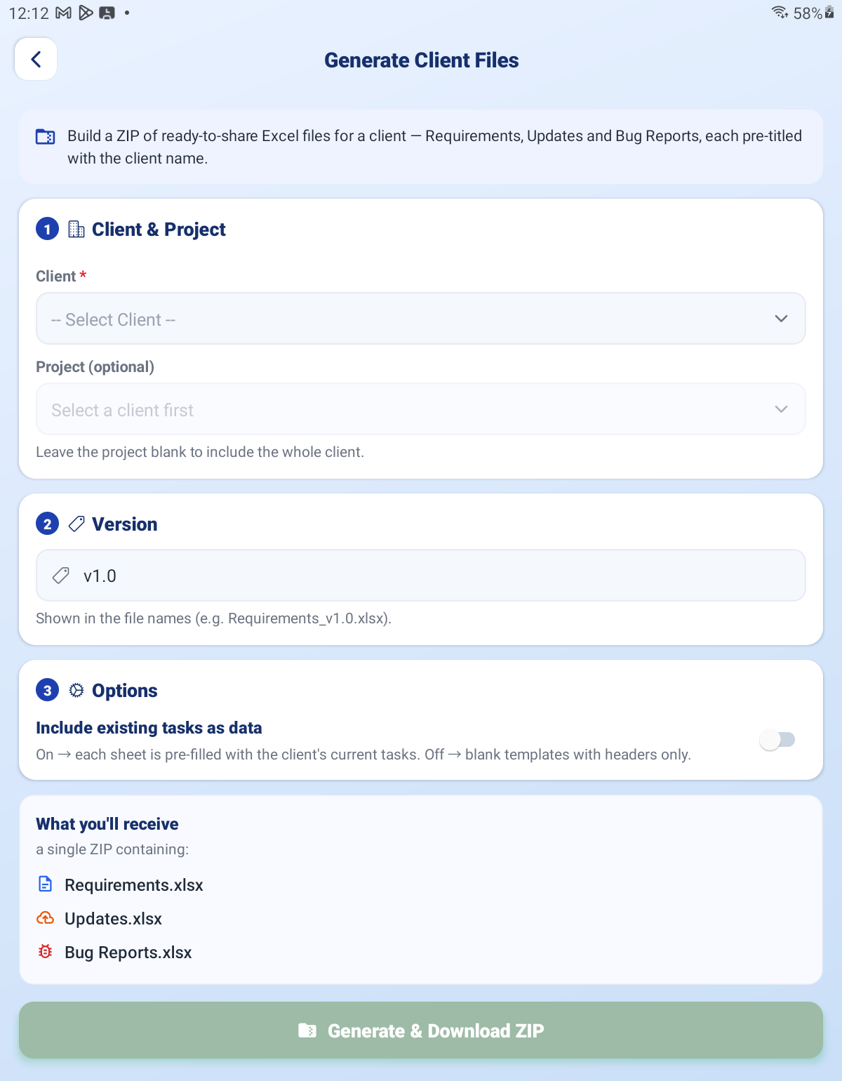
Generate Client Files — client, project and version pickers

PART 4 RUNNING THE DAY

Step 13 Watch Live Tracking
Open Live Tracking to see who is working on what, right now. It refreshes itself every 15 seconds.
What you see | What it means
Present | Started their workday on time and is here.
Late came 10:24 | Here, but started after the cut-off. The time shown is when they started.
Absent | Has not started their workday and the cut-off has passed.
Yet to start | Has not started yet, but it is still early.
Idle — no task running | Their day is running but no task is active. Worth a nudge.
Not started | No workday session at all today.

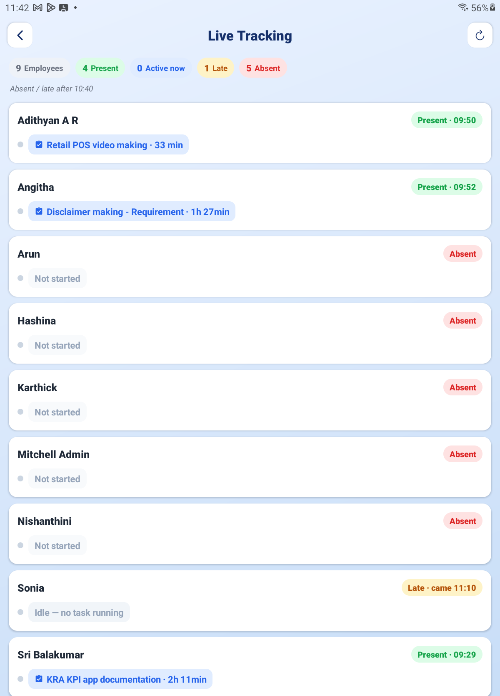
Live Tracking — the team list with attendance states and current tasks

Step 14 Use the Board as an Admin
Open KPI Action Board. A badge tells you whose tasks you are looking at — Coordinator · All for everyone's, or My Tasks for your own. Tap it to switch.
As an Admin your task cards carry extra buttons that Users never see: Accept, Reject, Approve, Revert, Reassign and Delete.
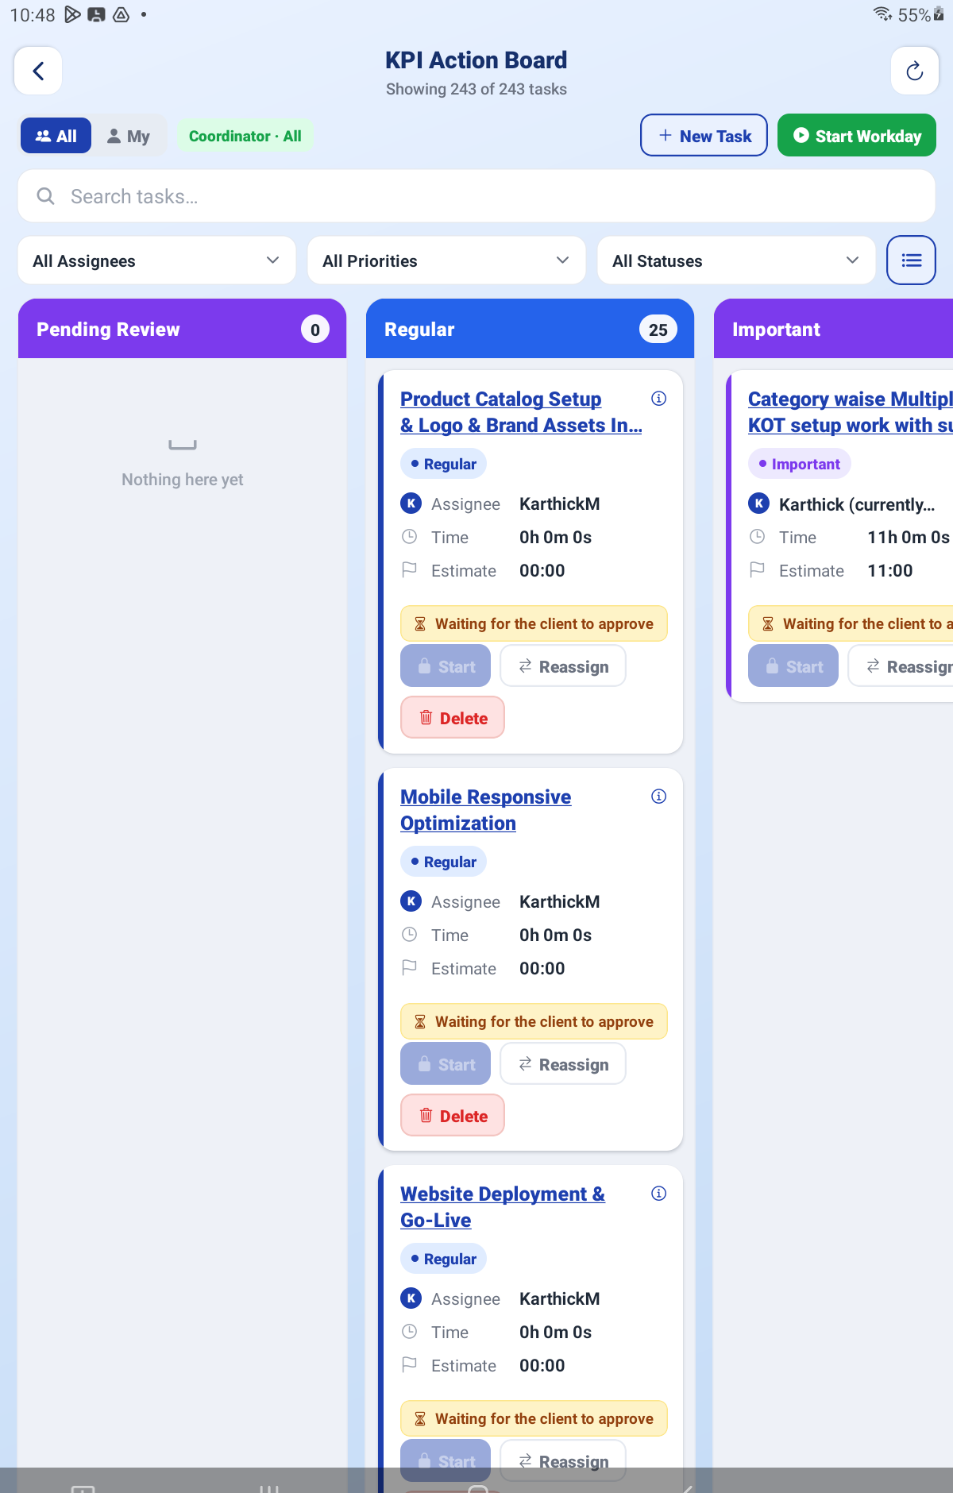
The Action Board as an admin — the “Coordinator · All” badge and admin buttons on a card

PART 5 TRIAGE AND APPROVALS
Work passes two gates before it can be billed. You control the first; the client controls the second.

Step 15 Accept or Reject New Tasks
When a team member raises their own task it lands in Pending Review. They can work on it straight away, but it does not count as billable until you accept it.
Tap Accept and set two things:
▪ Task type — Requirement (REQ), Update (UPT) or Bug (BUG). This decides how it is billed.
▪ Priority — which lane it belongs in.
What the developer asked for is shown next to your choice, for example “Developer asked for Urgent”, so you can see where you are overriding them.
Tap Reject to send it back with a note explaining what to change — for example “Wrong project — move it under Alphalize > Phase 2.”
TIP If nobody triages a task, it accepts itself after the time set in Configuration. The developer's card shows the deadline: “Waiting on admin — accepts automatically at 14:35.” Clear Pending Review each morning so the defaults are never what decides your billing.

Step 16 Approve or Reject Finished Work
When a developer taps Complete, the task moves to Pending Approvals and waits for you. Open it and tap Approve. A quality checklist appears — work through it:
▪ Task reviewed
▪ GitHub verified
▪ Testing completed
▪ Tested successfully
▪ User manual reviewed
▪ Documentation approved
Approving sends the task to Awaiting Client for sign-off. Tapping Reject instead sends it back to the same developer with your reason.

Step 17 Revert, Reassign and Delete
Button | What it does
Revert | Pulls a task back off the client's desk from Awaiting Client. Use it when you approved something too early. It will not work on a task the client has already signed off — that is a billing decision, not a workflow one.
Reassign | Moves a task to a different developer. Every reassignment is logged with its reason in Reassignment History.
Delete | Removes a task entirely. It only appears on tasks nobody has worked on — once time is logged against a task, the button is gone.

Step 18 Read the Task States
What a task calls itself on screen is not always what you would guess. This table maps the ones that catch people out:
On screen | What it actually means
Pending Review | Someone raised this themselves and you have not accepted it yet.
Verification Pending | A Partial Finish. The developer did what they could; you need to check it. There is no lane called “Partial”.
Pending Approvals | Finished by the developer, waiting on you.
Awaiting Client | You approved it; waiting on the client's sign-off.
Paused | Covers paused, on hold and sent-back-for-rework.
Completed | Client-signed-off. This is the only state that can be invoiced.

PART 6 REPORTS

Daily Reports
The system builds a daily task report PDF per person, on the schedule you set in Configuration. Open Daily Reports to View, Download or Share any of them.
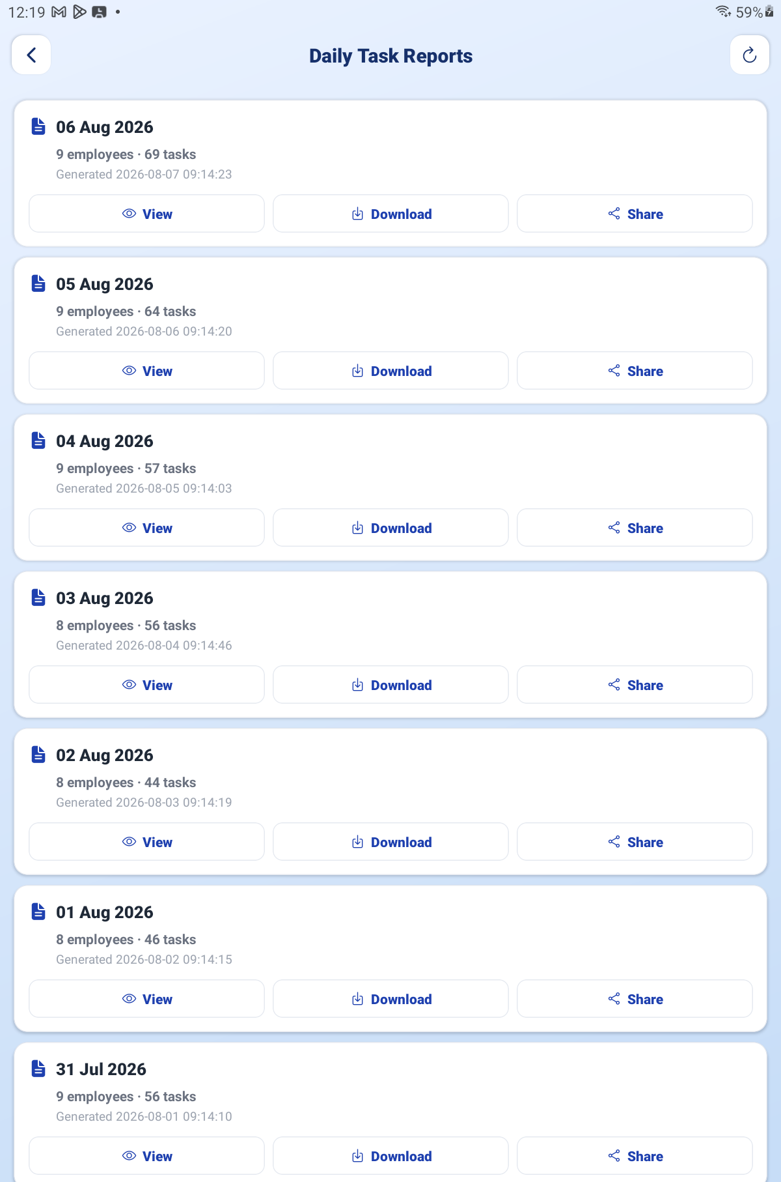
Daily Reports — the list with View / Download / Share

Work Report
Open Work Report to build a report over any period. Choose Today, This Week, This Month, Last Month or Custom; switch between Task-wise and Client-wise; optionally narrow to one client or leave it on All clients. Tap Generate, then PDF or Share.
TIP Client-wise over Last Month is the report to run before invoicing — it shows exactly what each client consumed.

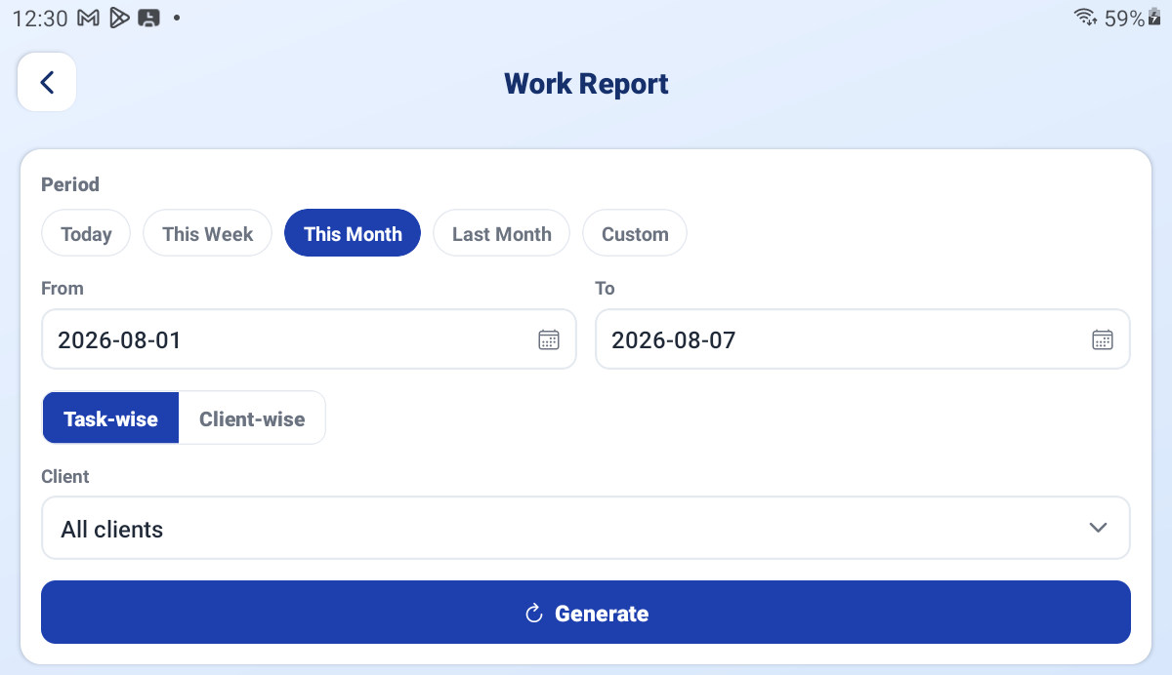
Work Report — period presets, Task-wise / Client-wise switch and Generate

Workday Snapshots
A saved image of every person's end-of-day summary. Drill down by date, then by developer, then open the image to View full size, Download or Share. How long these are kept is set in Configuration.
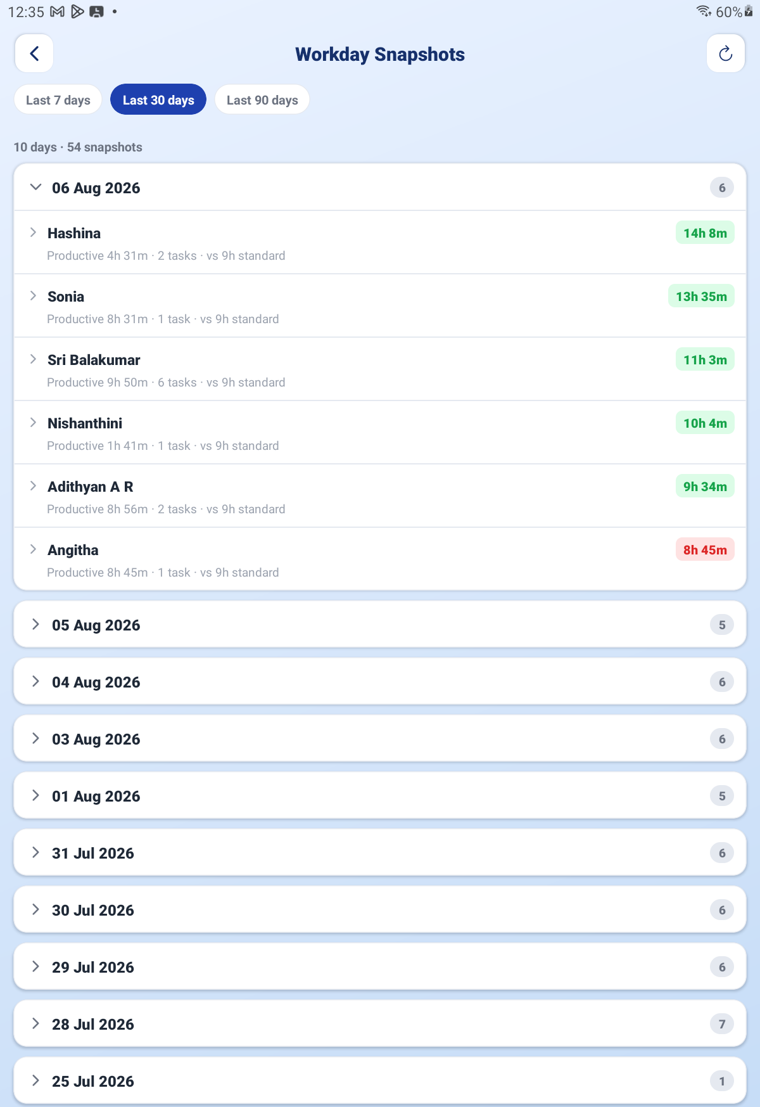
Workday Snapshots — date and developer drill-down

Reassignment History
A read-only record of every task that changed hands. Tap any entry for the reason and any pause information attached to it.
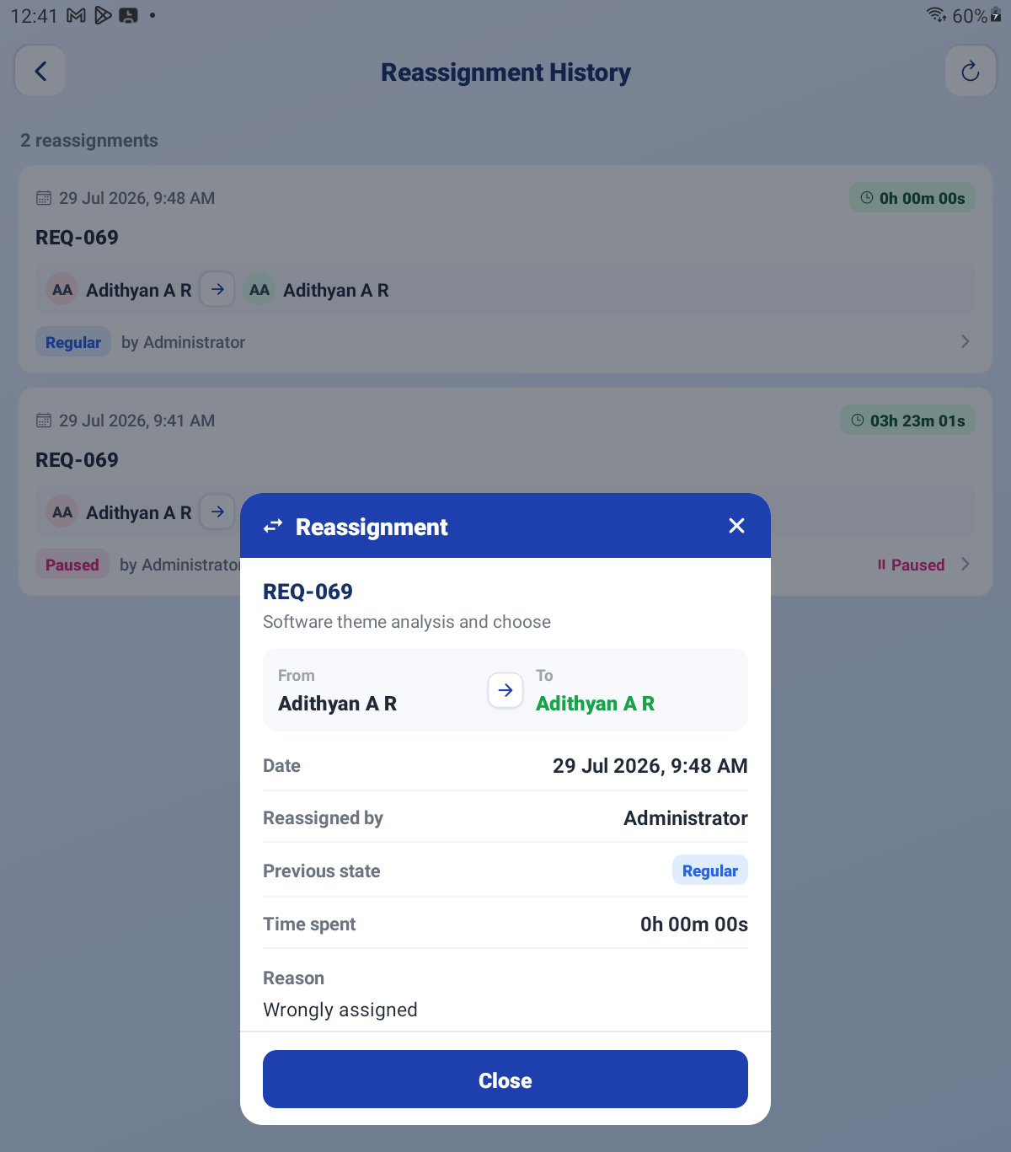
Reassignment History — the list and an opened entry

PART 7 INVOICING

Step 19 Find What Is Ready to Bill
Open Owner Dashboard. It shows certified tasks ready to invoice, grouped per client. Use Filter by Client or leave it on All clients, then View Certified Tasks to check the detail before you bill.
When you are happy, tap Generate Invoice and confirm.
IMPORTANT Only tasks the client has signed off appear here. A task the client auto-approved at the start is not billable — auto-release is permission to work, never permission to bill.

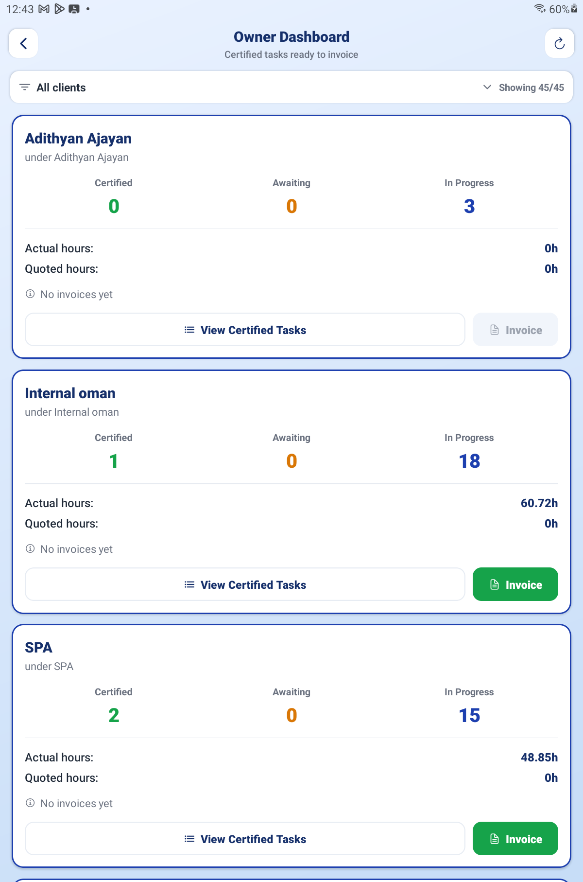
Owner Dashboard — per-client cards of certified tasks ready to invoice

Step 20 Create the Invoice
In Client Invoices, tap + to create one and set:
Field | What to set
Client | Who you are billing.
Billing method | Per Hour (time actually worked) or Per Task (a fixed price per task type).
Hourly Rate | Your rate, when billing per hour.
Currency | The currency to bill in.
Period | The date range to pull tasks from.
Include Task Types | Tick any of Requirements, Updates / Amendments, Bug Fixes. At least one is required.

You can add an ADJUSTMENT line for a discount or an agreed correction.
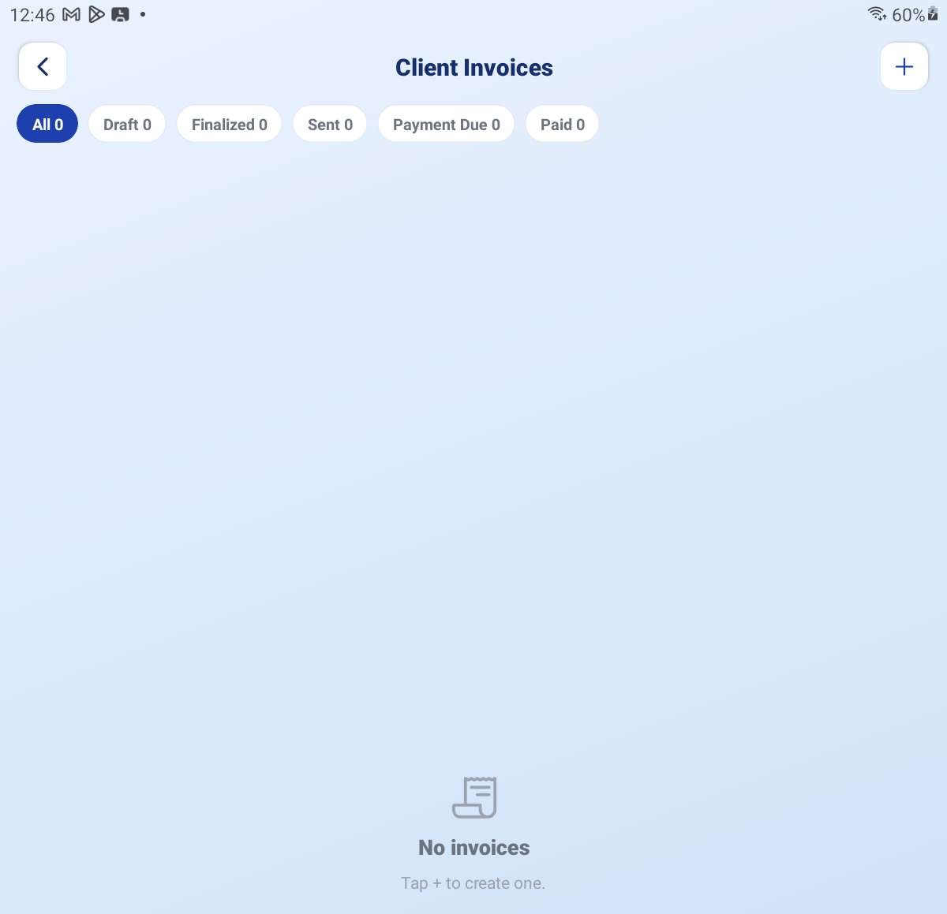
The Create Invoice form — billing method, rate, currency and task types

Step 21 Move It Through Its States
State | What it means
Draft | Yours to edit. The client cannot see it.
Finalized | Locked. Its tasks are now committed to this invoice.
Sent | Issued to the client. They can see it in their Invoices screen.
Payment Due | Issued and awaiting payment.
Paid | Settled. Use Mark Paid to set this, or Revert to undo a mistake.

Use PDF and Share to send a copy outside the app.
IMPORTANT Once a task is on a finalized or sent invoice it is locked and cannot appear on another one. This is what stops a client being billed twice for the same work. Check a draft carefully before you finalize it.

PART 8 PUBLISHING THE MANUALS

Step 22 Upload a Manual
Open User Manual and tap + Add. Set:
▪ Title — what people see in the list.
▪ Visible to — Everyone, Developer, Admin or Client.
▪ PDF file — pick the file from your device.
This is how these three guides get into the app. Upload each one against its own role:
File | Visible to
kra-kpi-admin-manual.pdf | Admin
kra-kpi-client-manual.pdf | Client
kra-kpi-user-manual.pdf | Developer

Role filtering is enforced on the server, so a client can never open the admin guide even if they know it exists. Only admins see + Add, Edit and Delete.
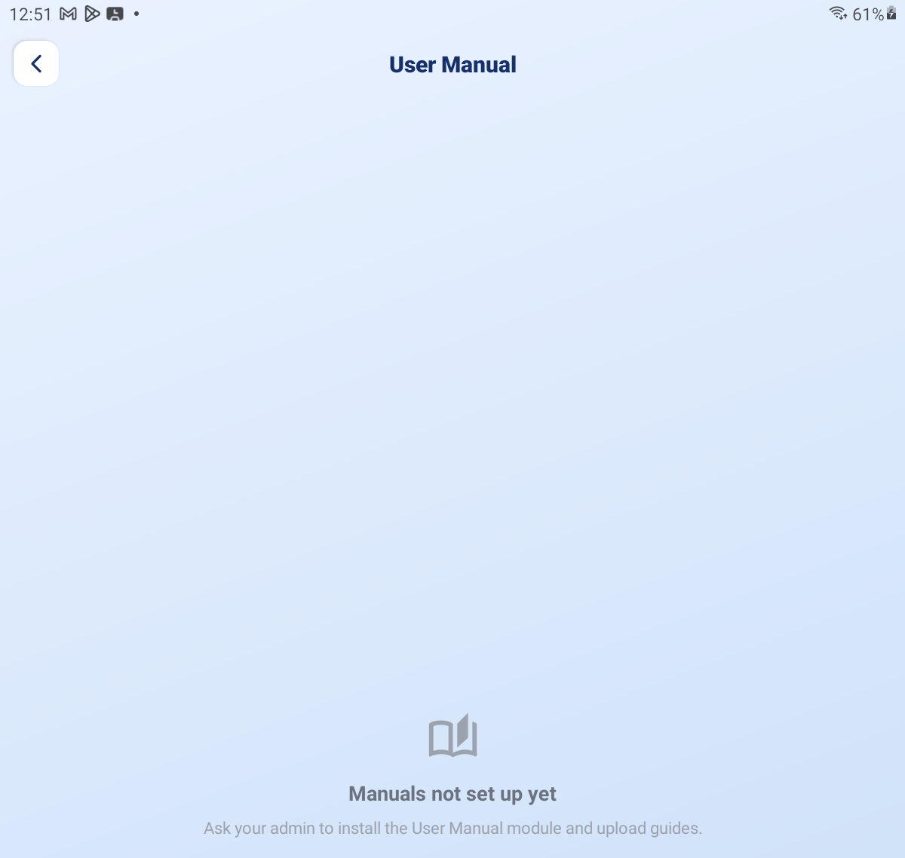
User Manual — the + Add form with Title, Visible to and PDF file

PART 9 WHAT THE APP TELLS PEOPLE

The Four Channels
Channel | Used for
In-app notifications | The bell on Home. Everything is recorded here, sorted into All / Unread / Action needed. Cleared automatically after 30 days.
Push notifications | Alerts on the phone even when the app is shut. Tapping one opens the exact task, report or invoice.
Task alarms | Full-screen, ring-out-loud reminders that team members set on their own tasks. You do not set these for them.
WhatsApp | Login codes, and the client approval links.

What You Get Told About
▪ A team member raised their own task and it needs triage
▪ Someone finished a task and it needs your approval
▪ A client approved, rejected or held an assignment
▪ A client signed off finished work
▪ Someone paused a task as Urgent — these carry a red URGENT badge and are chased until read
▪ Someone reported they have no tasks
▪ A workday was closed automatically at midnight
▪ The daily report is ready, and invoices are issued or paid
TIP The Action needed tab on the notifications screen is the shortest useful list in the app — it is only the things that will not move without you. Check it first each morning.

QUICK REFERENCE

Who Can Do What
Action | Admin | Client | User
Start / end a workday | Not required | Not required | Required
Work on tasks | Yes | No | Yes
Create a task | Yes | Via upload | Yes (New Task)
Accept / reject new tasks | Yes | No | No
Approve finished work | Yes | No | No
Approve the assigned developer | No | Yes | No
Sign off delivered work | No | Yes | No
Reassign / delete a task | Yes | No | No
See everyone's tasks | Yes | Own only | Own only
Create invoices | Yes | View only | No
Change configuration | Yes | No | No
Upload manuals | Yes | No | No

Things to Remember
▪ Clear Pending Review every morning. Anything you leave accepts itself on the timer, and then the default has decided your billing.
▪ Only client-signed-off work is billable. Auto-release lets work start; it never authorises an invoice.
▪ Deleting a KRA deletes everything under it, with no undo.
▪ A task on a finalized invoice is locked and can never be billed again.
▪ If people cannot get login codes, check the WhatsApp sender in Login Management first.
▪ Verification Pending on the board means a Partial Finish, not a completed task.
▪ Configuration saves as you type — there is no Save button, just the tick.
▪ Set Company Branding before sending your first invoice; it is what the client sees.
▪ If a screen looks stale, pull down to refresh, or return to Home and open it again.
Triage in the morning, watch the day, approve as it lands, and bill what the client has signed. That is the whole rhythm.

— End of Guide —
Alphalize | KRA / KPI Admin Guide

